MongoDb and Pandas CRUD operations.

Assignment: 5

Step1: Download mongodb

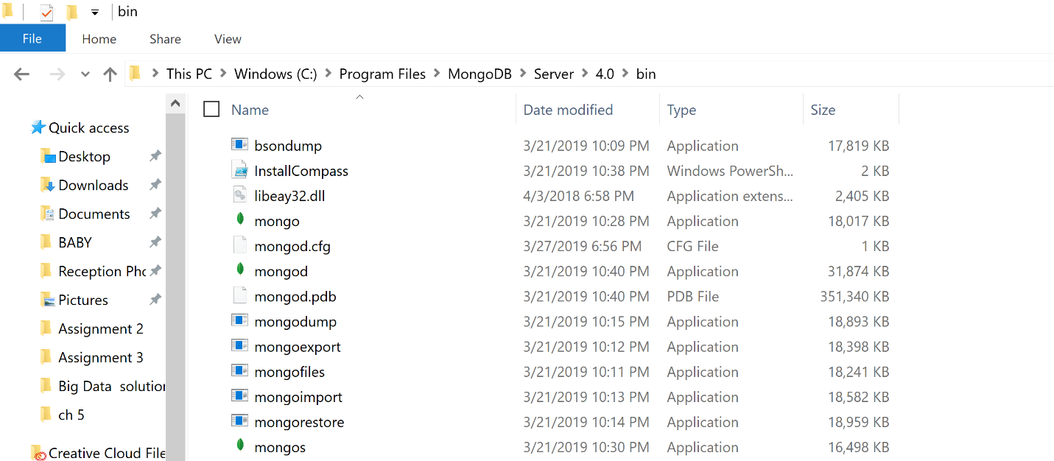

Step2: Inserted JSON file to test MongoDB is working or not.

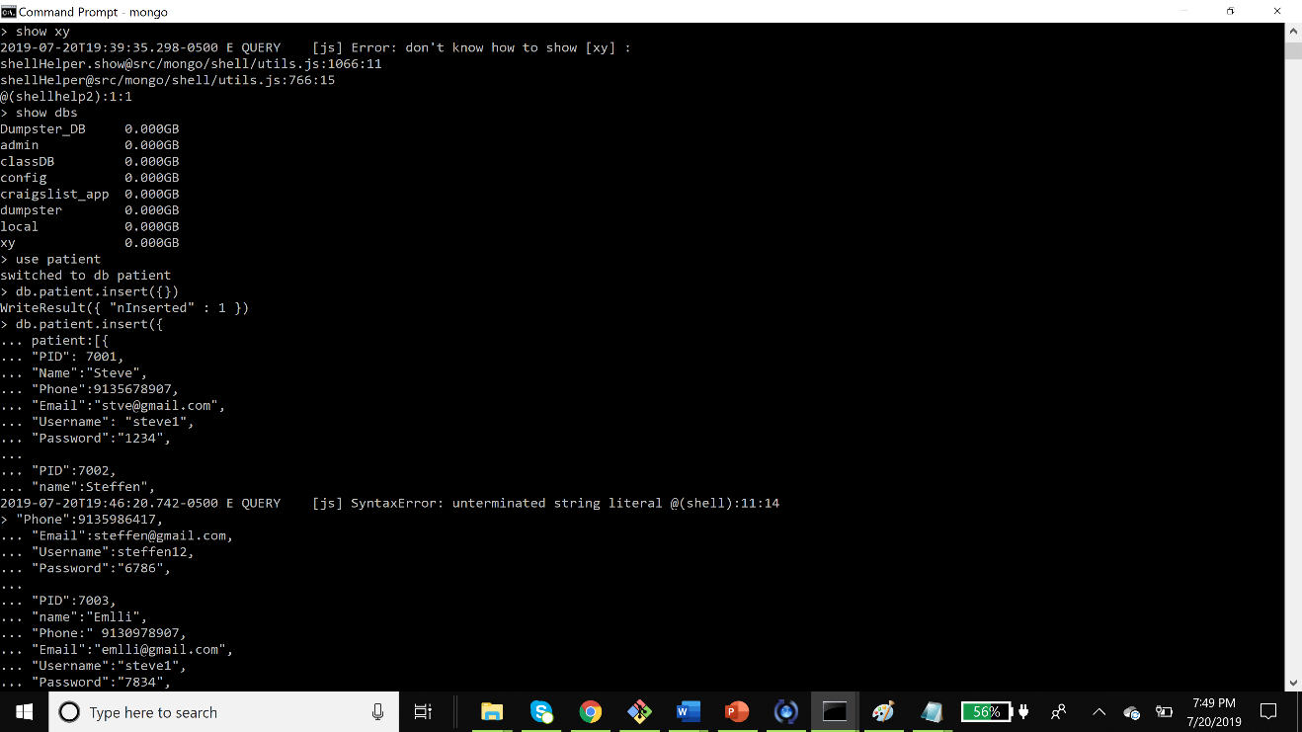

Step3:Created database PatientsInfo in MongoDB Atlas.

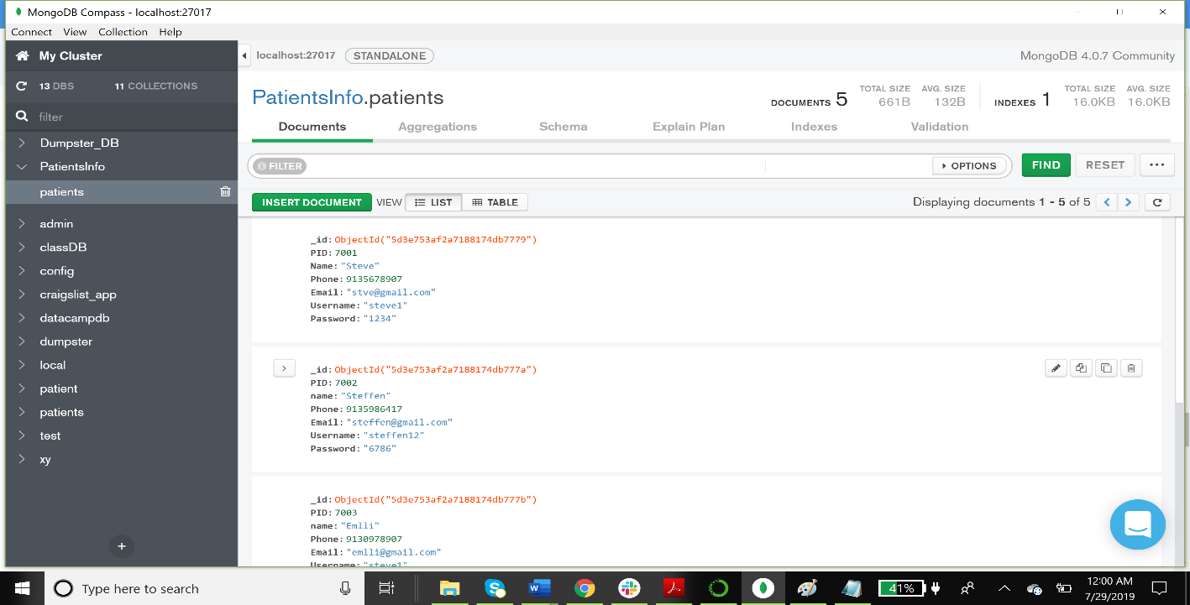

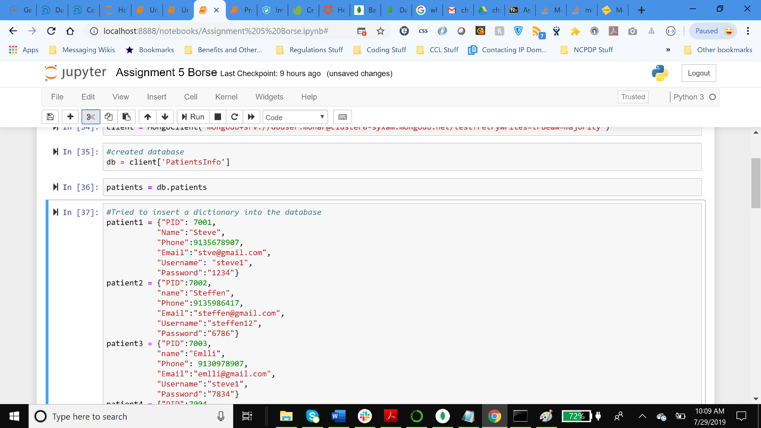

Step4: Tired to perform the crud operations on mongodb database.

1. Used Remove command to remove the first entry with PID 7001

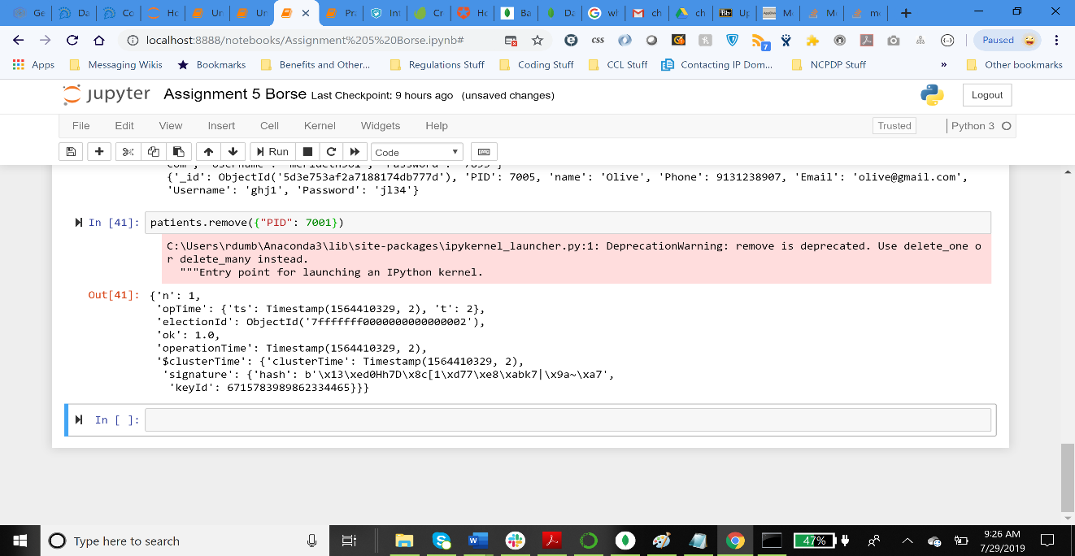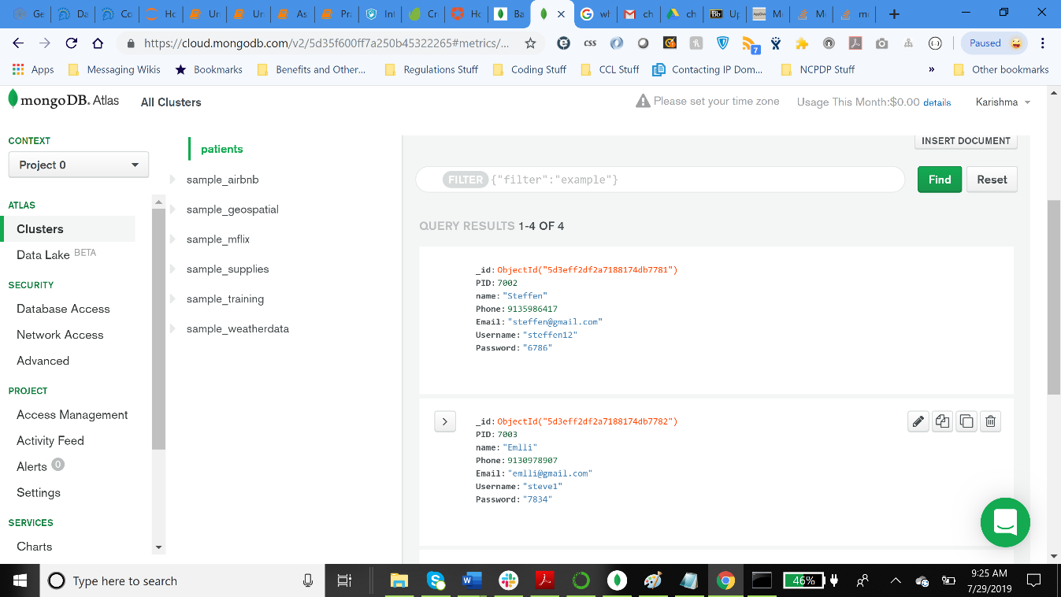

1. Used update command to change the name of the patient from Steffen to George and printed.

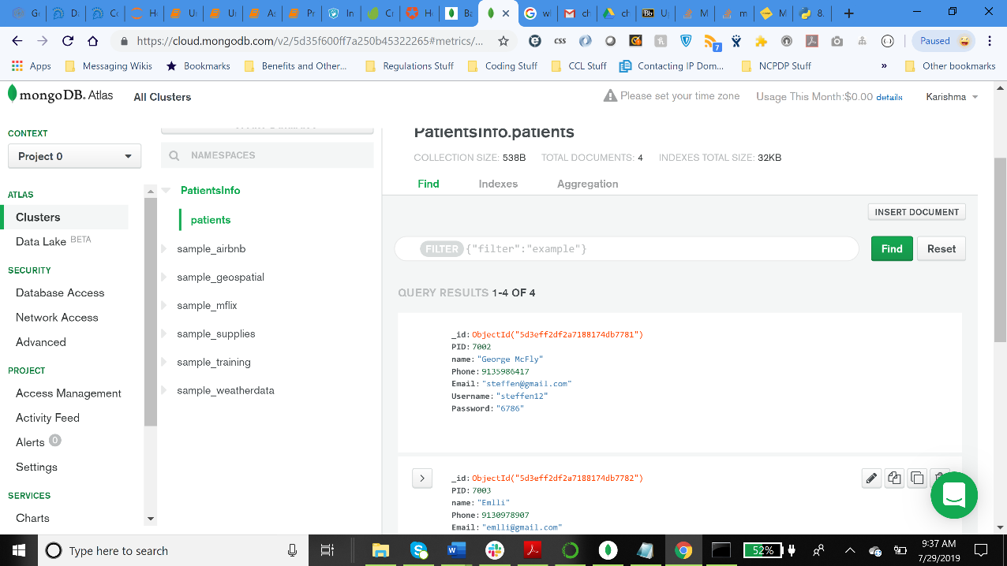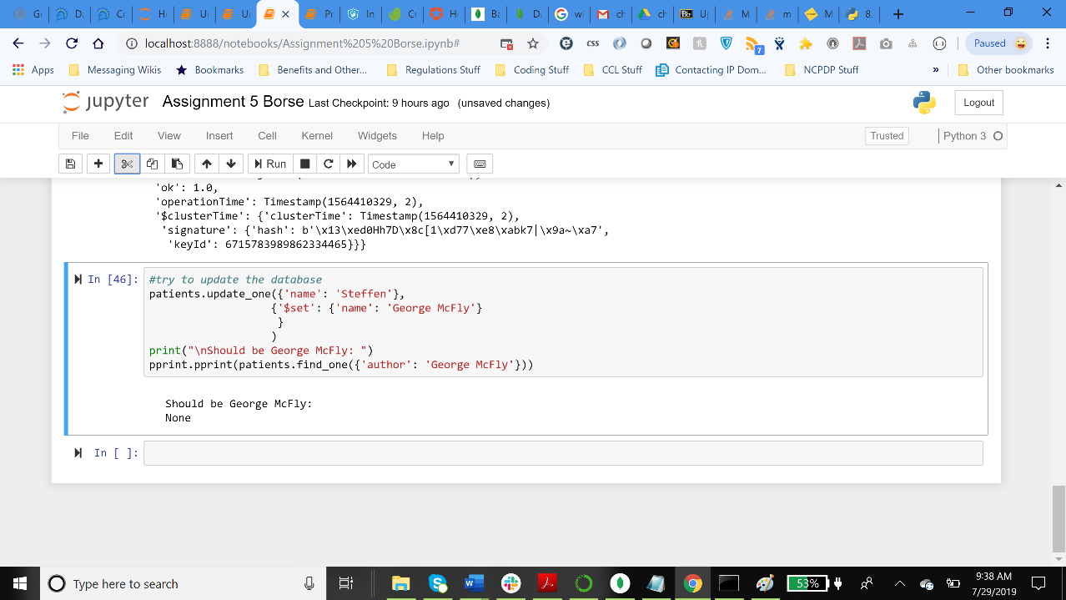

1. Used “Find” command and printed the database.
2. 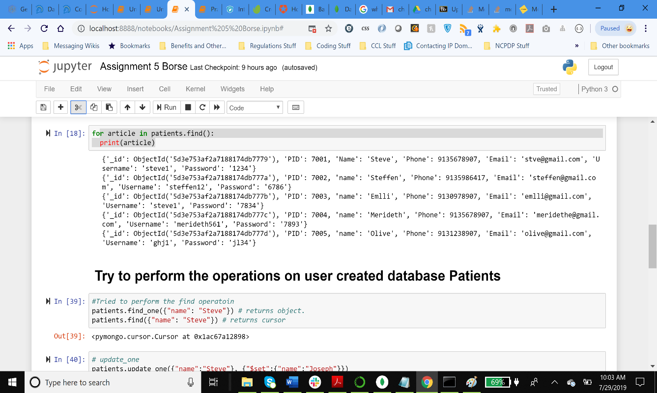

**Issues faced:**

1. Received an error message “dnspymongo” module should be installed to set up the connection.

Solution: opened git bash and tried to install “pip install pymongo” but this module was already installed into my system. Then tried to install “pip install pymongo[srv]” and the connection was successful.

1. Tried to use my ip address to build the connection but it failed then I googled “whats my Pc’s IP address” and it showed IPv6 address which was not supported. Then Tried to use 0.0.0.0/0 which is a global IP address which authenticates any user from globe to make changes into cloud which is not preferable.
2. For “Bad Authentication” error Removed “<>” signs between password from the connection string.
3. For “user is not allowed to make changes into admin “ error- changed the Database Access settings- edited the user(dbuser) database read and write only settings to admin privileged and “readandwrite any database”.